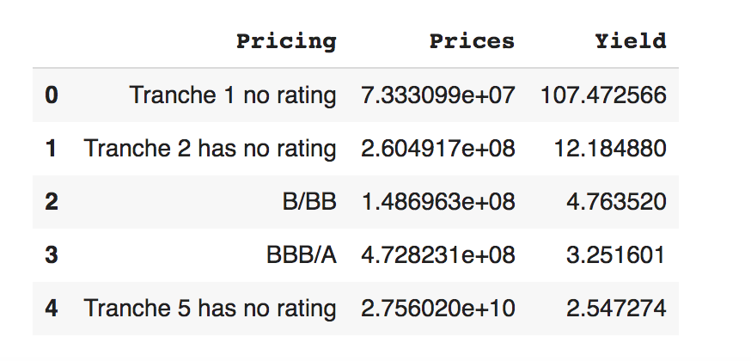

**Pricing**

**Prices**

**Yield**

107.472566

0 1

Tranche 1 no rating 7.333099e+07 Tranche 2 has no rating 2.604917e+08

B/BB 1.486963e+08

BBB/A 4.728231e+08 Tranche 5 has no rating 2.756020e+10

12.184880 4.763520 3.251601 2.547274

4